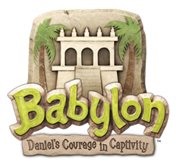

Adult Volunteer Sign-Up Form
June 18-22, 2018 ◊ 8:45 am- 12:30 pm

Name:
E-mail Address: Cell Phone #: ( )
T-shirt size: (please circle) S M L XL XXL
Please circle the areas you would like to help with:
*Childcare
*Classroom Teacher - circle preferred grades: 4’s/TK TK/K 1st 2nd 3rd 4th 5th/6th
*Recreation
*Arts and Crafts
*Music
*Exploratorium
*Snacks
*Decorating / Set-Up
*Skits
*Put me where you need me!
Are there any days you cannot be here? Yes / No Circle days you CANNOT work: M / T / W / Th / F
Is there someone in particular with whom you would like to work?
Please Circle: Church Member? Yes / No

Thank you for volunteering to help with Vacation Bible School this year!
Questions? Please contact Matt Williams matt@saintjohns-charlotte.org

Please return this form to Matt Williams’ box or the VBS Folder at the receptionist’s desk.

