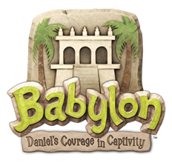
Better put those VBS dates on my calendar right now!

Youth Volunteer Sign-Up Form
June 18-22, 2018 † 8:45 am- 12:30 pm

Name: Age:
Rising School Grade (2016-2017): 7th / 8th / 9th / 10th / 11th / 12th / College
T-shirt size (circle one): YL AS AM AL AXL AXXL
E-mail Address: Cell Phone #: ( )
Mother’s Name: Mother’s cell or work #: ( )
Father’s Name: Father’s cell or work #: ( )

Please circle the areas you would like to help with:
*Childcare
*Classroom Help - circle preferred grades: 4’s/TK TK/K 1st 2nd 3rd 4th 5th/6th
*Recreation
*Arts and Crafts
*Music
*Snacks
*Put me where you need me!
Are there any days you cannot be here? Yes / No Circle days you CANNOT work: M / T / W / Th / F
Please Circle: Church Member? Yes / No

Thank you for volunteering to help with Vacation Bible School this year!
Questions? Please contact Matt Williams matt@saintjohns-charlotte.org

Please return this form to Matt Williams’ box or the VBS Folder at the receptionist’s desk.

