6th / 7th Sunday School Calendar St. John’s Youth Ministry 2017-18
September 2017  3rd No Class (Labor Day)  10th Welcome and Getting to  Know You!  17^{h} Jr Fall Retreat – Games  24th Beginnings: Creation | October2017  1st Beginnings: Fall  8th Beginnings: Suffering  15th Beginnings: Flood  22nd Beginnings: Tower of Babel  29th Beginnings Rewind | November 2017  5th Promise: Covenant  12th Promise: Jacob and Esau  19th Church in the World – No  Sunday School  26th Promise: Jacob to  Israel | December 2017  3rd Promise: 12 Sons  10th Promise: Joseph  17th The Promise Rewind  24th No Sunday School  31st No Sunday School
January 2018  7th Freedom: Moses  14th Freedom: Exodus  21st Freedom: Wilderness  28th Freedom:  Commandments  (Winter Retreat Weekend) | February 2018  4th Freedom: Promised Land  11th Freedom Rewind  18th Kings and Prophets:  Judges  25th Kings and Prophets:  David | March 2018  4th Kings and Prophets:  Solomon’s Temple  11th Kings and Prophets:  Kingdoms  18th Kings and Prophets:  Prophets  25th Kings and Prophets  Rewind | April 2018  1st No Sunday School  (Easter)  8th Conquered: Babylon  15th Episcopal Visitation – NO  CLASS  22th Conquered: Diaspora  29th Conquered: Return
May 2018  6th Conquered: Occupation  13th Conquered: Caesar  20th Jr. EYC Beach Trip - games  27th No Class (Memorial Day) | June 2018  3rd Sundae Sunday | Curriculum: Connect by Sparkhouse  (see description on back) | 6th / 7th grade teachers:  Candler Tindall  Bill Kessler
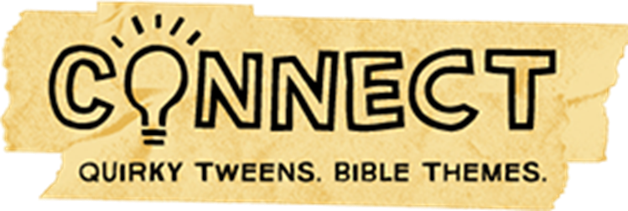
Connect Curriculum Overview
At St. John’s, in 6th and 7th grade, we spend the two years doing an overview of the Bible! The goal of these classes is threefold: to review some of the Bible stories learned in childhood; to begin preparing for confirmation; and to encourage youth to think about how Scripture relates to the life of a 6th or 7th grader!
We use a curriculum called Connect (by Sparkhouse). Connect engages preteens in God’s big story through videos (with a set of quirky characters/hosts that show up weekly), Bible exploration, and hand-on projects.
The curriculum includes 10 total units that are covered in two years! Year A focuses on the Old Testament and year B focuses on the New Testament. Last year we covered Year B. For the 2017-18 school year we will cover Year A. In 2018-19 we will go back to Year B!
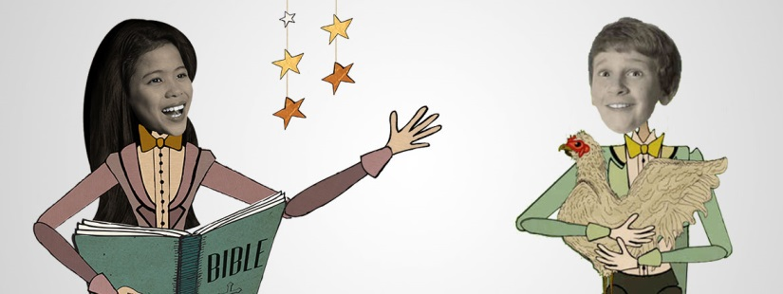
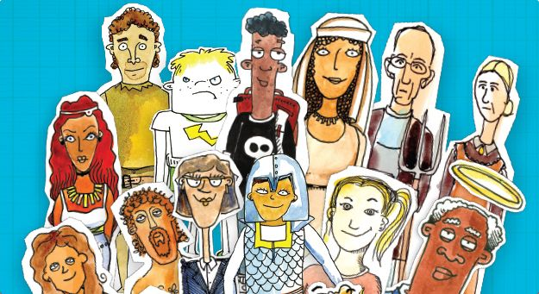
aracte quirky characters
(Video hosts!)
(Video Characters!)
Why Do We Use Connect at St. John’s?
We like Connect for because it offers:
- A Bible Centered Approach
Encourages kids to see the narrative arc of Scripture.
- It’s not “Little Kid” Sunday School
The curriculum was developed just for tweens; it blends quirky humor with solid theology.
- Engaging Videos
Each lesson begins with a video that blends humor and theology in a way that is accessible to preteens.
- A Foundation For Faith
Connect helps students make sense of the Bible, encourages them to ask questions, make connections, and reflect.

