9th – 12th Grade Sunday School

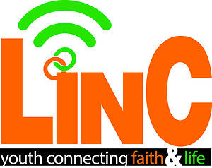

LinC Curriculum Overview

A fresh, timely, and biblically based resource, LinC helps teens examine relevant faith and life issues using the latest music, movies, news, and current events. Our goal for these classes is that through engaging Bible study, youth will feel equipped to evaluate their world from a biblical perspective!

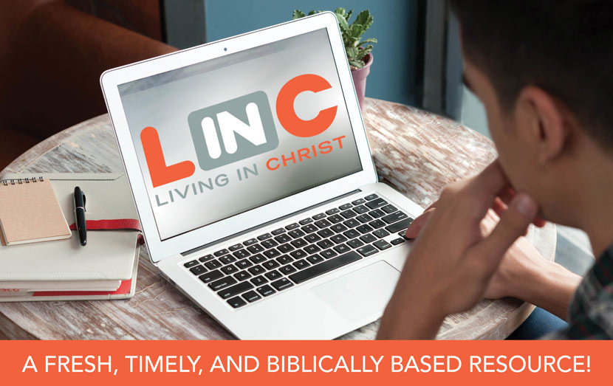

Class Teachers

Patrick Leake Phil Asby

This curriculum is written (by teen culture experts) on a weekly basis and is based on music, movies, and current events! Topics will vary weekly based on media and worldly happenings.

Past Topics Have Included:

The Drive For Perfectionism  
The World of Alliances  
New Year, New You  
Sacrificial Love  
When Disaster Strikes  
Loving the Lonely  
Sharks, Alligators, and Bears, Oh My!  
Niceness Vs. Kindness  
We, the People

(Video Characters!)